**If you are having hard time solving problem just read the question word by word or if it is diagram then see it carefully and see the magic !**

**Engineering Mathematics** :

1. The number of subwords of w = ‘SCALABLE’ is equal to 1+2+3+…+8 but you have counted A and L two times in strings of single length. So do not forget to subtract 2.
2. Cov(X,Y) = Var(a+b) where a, b is constant. This is actually not correct but see how it is correct. If a and b were not constant then it was incorrect. But var(constant) = 0 and so Cov(x, y) = 0.
3. If eigen values are distinct then matrix is diagonalizable.
4. |x| = y is continuous but not differentiable. Continuous because it is not giving any undefined value at some point. But it is not differentiable because at x = 0 it has -1 and 1 slope. But has minimum value at x = 0. So it is possible for a function to not be differentiable but have minimum value.
5. 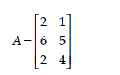Here rank of matrix is 2 and Nulity = minimum order is 2 – rank of A = 0.
6. If you are to find A-1 without using adj(A) then use this : 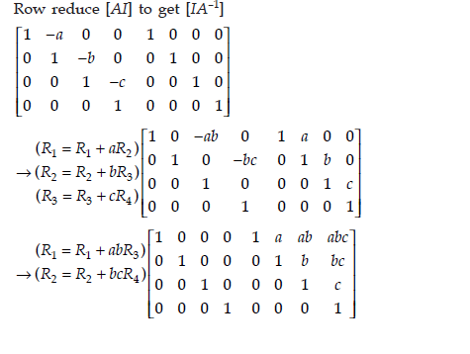In this we only apply operation on row and convert our original matrix to identity matrix.
7. May or may not be accurate means indirectly false. Not 100% true.
8. 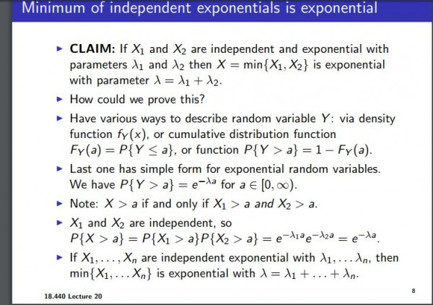
9. If all the principal minors of A are positive , all the eigen values of A need not be positive.  Principal minors means diagonal values.

**Discrete Mathematics** :

1. Disjoint : Intersection of each set is NULL. So, P(AB) = NULL.
2. Size of graph means total number of edges.
3. 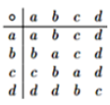One more condition to check weather set is not group. Here identity element is a. first check for identity condition. i.e. a*(any) = any. Second check for inverse i.e. (any)*(inverse) = a. that means a should be present in row once. As you can see d does not have inverse. So not group.
4. 3 colorable meaning tripartite graph.
5. 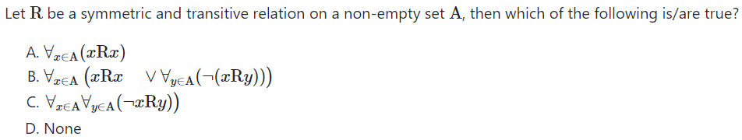

Option B is correct. See nothing is given such that xRy is correct or incorrect. xRx will be always true. But there exists other xRy which might be true or which might be false, it is true then we have to include it if it is incorrect then we do not consider it. first option is correct but do not cover xRy.

1. Any graph that does not contain a triangle is 2-colorable. This is looks true but consider Cycle5 graph in which there is no triangle but still graph is 3 colorable. In this type of question try to make counterexample rather than guess.
2. Line graph of complete graph is not always complete, line graph of bipartite graph is not always bipartite and line graph of connected graph is always connected.
3. When there is a function from A to B and |A|<|B|. then one thing is clear that it is not onto function.
4. f:R→R,f(x)=x2 this function is not injective because 1 map to -1 and 1. This is not surjective also as x2!=-1. Read the question it’s R→R.
5. If graph is planar then its chromatic number will be less than 5 but vice versa is not true. Counterexample will be K3,3 graph in which chromatic number is 2 but it is not planar.
6. This is very tricky and hard to notice. 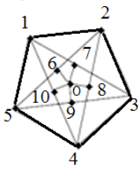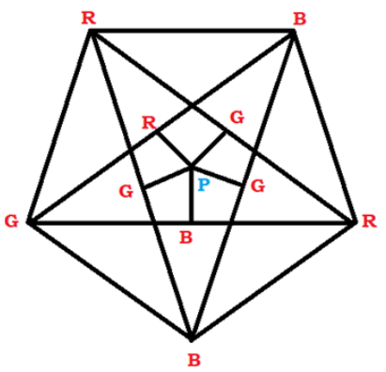Chromatic number is 4!!!
7. 3 equivalence class with 6 element are 4,1,1 || 2,2,2 || 1,2,3. Now square and add so you will get cardinality of relation.
8. Relation (1,1) (2,2) (3,3) on set S={1,2,3} is both equivalence and partial order which is one and only one.

**Digital Logic Design** :

1. 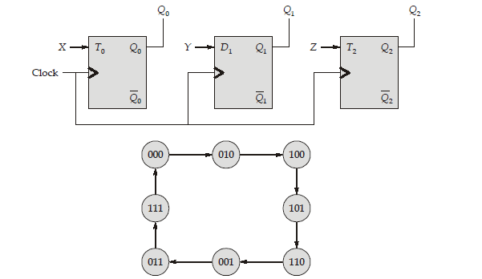in such type of sums draw table and make kmap of x,y,z.
2. Assuming that the input ABCD = 0110, ABCD = 1001, ABCD = 1011 never occur this sentence mean that these combinations are do not care terms.
3. Read carefully if Product of sum or sum of product is given in question.
4. Number of minterm and maxterm means consider 0, 1, 3. Do not consider x’y’z or something like that. These all are minimal product of sum or sum of product expression.
5. 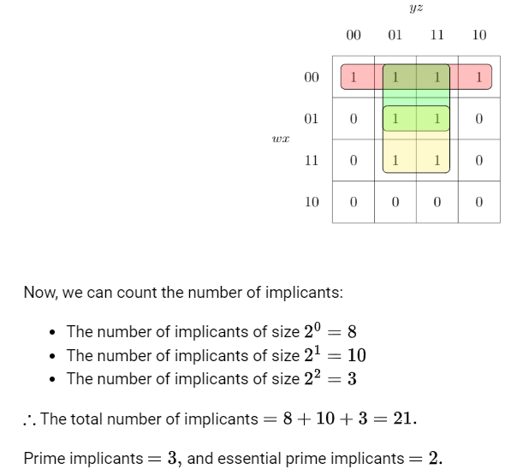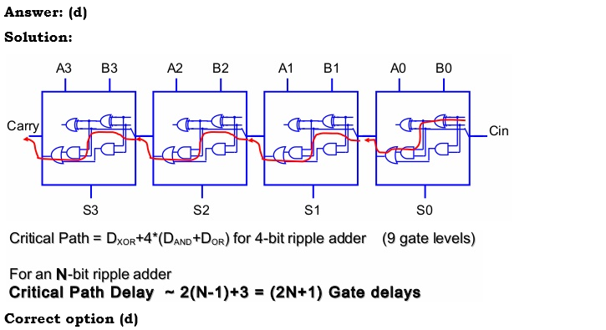

Carry in first stage propagate through three gates as and then one carry is already been calculated by second stage so it need not to be passed through one gate so overall delay of carry is 3+2(n-1) = 2n+1.

1. Both are same difference is one is minimal so if it is not asked in question that select minimal then select both.
2. There is no such things as analog device and digital device.
3. 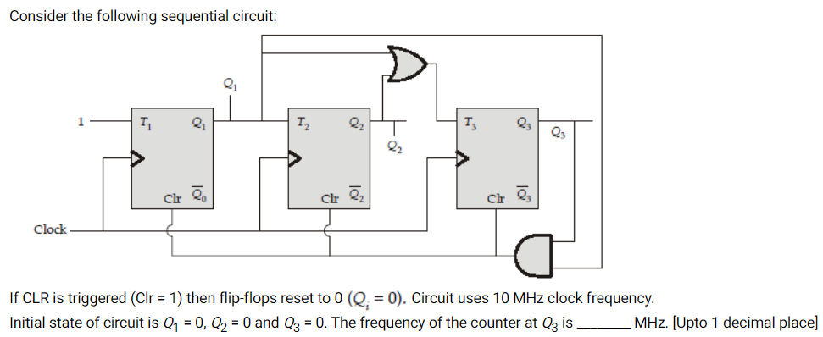read the question carefully you were doing right but when state becomes 101 or 111 it reset flipflop so you get only 5 state instead of 8. Cal frequency.
4. 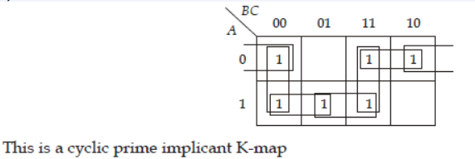

**Computer Organization and Archi** :

1. Position-independent code means sentences like goto L1, goto L2. Which uses Relative addressing as it requires [PC] + @constant.
2. Let there be P locations in primary memory and C locations (lines **not sets**) in the cache. The different locations in primary memory map to a particular location in the cache is
3. In Direct mapping : P/C
4. In fully associative : P
5. In set associative : if K way then KP/C.
6. One stage including buffer register store time = 1 cycle time. 1 cycle time = (max stage time) + intermediate register transfer time.
7. Speedup = 1/(serial + parallel/n). It is 1 divided by don’t forget.
8. Note if it is given in question that a page is found in TLB or in page table, directly you can calculate total access time. You just add access times of TLB + Page table + 2 x (if dirty bit is given then consider disk time). Why 2 because time to swap in frames from memory to disk and then from disk to memory.
9. If virtual address are given for example 10451 and page size = 2000 byte then we know 2000 x 5 + 451 = 10451 so, 5 becomes page index and 451 becomes offset.
10. Fully associative is also called associative (only).
11. 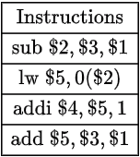if you calculate cycle you will get 8 as answer. But 9 is correct see instruction 3 which uses the value of $5 which the content of 0($2) after 2nd instruction. Second instruction produces effective address after EX stage. Then in forth stage you will have content of $5 so there is stall of one cycle. So be careful with ALU operation after load instruction.
12. Effective CPI = average CPI + instruction miss cycle + data miss cycle … Which means average CPI + memory stall.
13. If nothing is mentioned about non-pipeline CPI consider it as number of stages so lets say number of stages are 5 then speedup = 5/(1+penalty in pipeline)
14. In case of finding speed up between two processes where cycle time and CPI is given. In this type of question first find average instruction time means (second/instruction) not (instruction/second). Second takes per instruction.
15. Many to one or one to many is user to kernel mapping not kernel to user mapping.

**Data structure and C programming** :

1. We get runtime error (segmentation fault) if we try to access some invalid memory. If we add number to address then it’s not runtime as we are not accessing anything.
2. 0b – Binary, 0 – Octal, 0x – Hexadecimal
3. **a?b:c** this if statement can be implemented following : **{(-!!a) & b} | {(-!a) & c}** Where – is 2nd complement because number in negative is represented in 2nd complement, ! is logical not which gives 1 when non zero number and 0 when 0.
4. If we have 2 sorted array of size 2 then median of combined sorted array will be (max(a1[0],a2[0])-min(a[1],a2[1]))/2. So you can generalized this idea if you have two sorted array of size n then you can find combine median log n time complexity by divide and conquer.
5. Do not follow your old knowledge, like 4th largest element in max heap. It is at level 4. Because we can have chain like structure.
6. Every recursive program has same power as iterative program.
7. 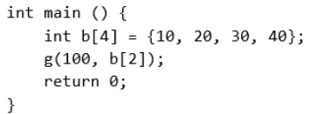 Here in g function b[2] is not array it is b[2] = 30; so 30 will be passed. This is so stupid.
8. Adding and removing element from linked list is simple as compared to array because if index or pointer in case of linked list is given then we can simply delete the element in case of array we have to copy all the upcoming element. In insertion if node position is given then same as array we have to move all elements in array.
9. 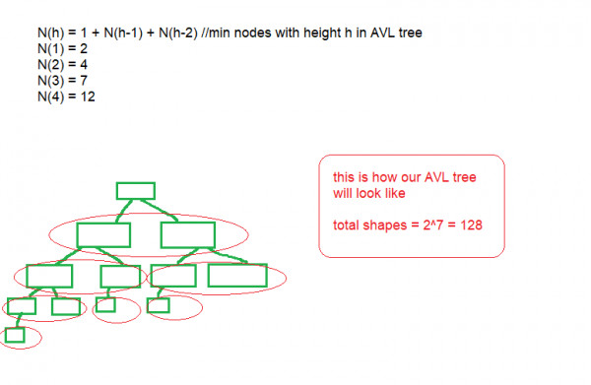Number of different shapes of AVL tree having height 4. Make one diagram then do mirror operation.
10. s[i] <= 'm'? s[i++]++ : s[i]+2 #This statement can be seen as if(s[i]<=’m’){s[i++]++;}else{s[i]+2;}
11. primary clustering can not happen in quadratic hashing. Only secondary can happen. Double hashing only slightly suffers from secondary clustering and does not suffer from primary clustering.
12. Look at page no 57 of your notes. Precedence table.

**Introduction to Algorithms** :

1. Worst case split up happens when pivot element is either maximum or minimum element of array.
2. If worst case is given even for merge sort select worst case for example merge sort has worst case O(nlogn) which is nothing but O(n2). So, select this option also.
3. 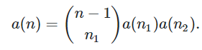 this is the recurrence relation of max heap or min heap. N1 and n2 represents number of nodes in left and right subtree. a(0) = 1, a(1) = 1, a(2) = 1. Why n-1 in recurrence relation because min or max is fix at root so we have to first choose right nodes from n-1 and then we check for combination and then we left with n-1-n1. With these nodes we check for combination.
4. If after doing recurrence relation you are come up with GP series then two cases are possible.
5. GP is increasing so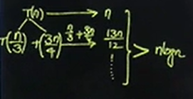 b. GP is decreasing then 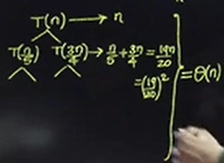
6. If the recursion does not have termination condition it will not go into infinite loop. Understand this when we call function it will get push into activation record now if it keep pushing function it will result in stack overflow in program it shows abnormal termination message.
7. Dijkstra’s algo is for shortest path it is not for spanning tree. Remember this.

**Theory of Computation** :

1.  this is regular. As set is of power 8 means it will create all strings of length 8.
2. There is infinite non-regular language. Non-regular language means it cannot be expressed by expression. So, L = {0n, n is prime} is non-regular and similarly complement of L’ is {0n, n is composite number} which is non-regular language. L.L’ (concatenation) is {0n, n>=6} which is regular.
3. That 2n-1 production is applicable for grammar which is in CNF.
4. L∘∅ = ∅. Dot is concatenation operator.
5. For all languages L1,L2,L3⊆Σ∗, we have L1∘(L2∩L3)=(L1∘L2)∩(L1∘L3). This is false. Consider L1 = {b, ε}, L2 = {a}, L3 = {ba}. Dot operator do not follow distributive property.
6. Number of DFA having M state and N symbol. So let’s break this 1) find number of initial state which can only be one in any DFA so there are M state so M choice. 2) transition function : This is basically meaning number of edges in DFA so DFA have transition function like Q x Z -> Q, which is nothing but M x N -> M, which nothing but function from MxN to M which is MMN. 3) Number of final states : final can be null or more than null. So 2M. Multiply all 3 together we get. MMN+1 x 2M. You can apply same technique to solve for NFA.
7. Myhill-Nerode equivalence means your equivalence class (see notes) which is nothing but fancy name for number of states.
8. Non-regular grammar can also produce regular language. G->SS|a is non regular because read page number 8 of notes if you don’t know. But this grammar produces regular language.
9. 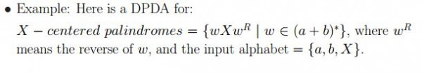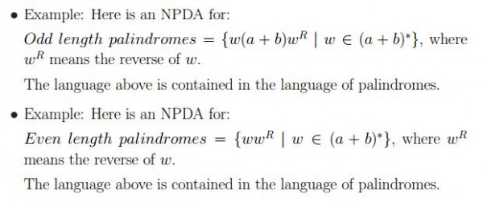
10. Don’t make silly mistakes This is regular as equation is less than and it is finite solution so plz. Do not make conclusion think about it.
11. 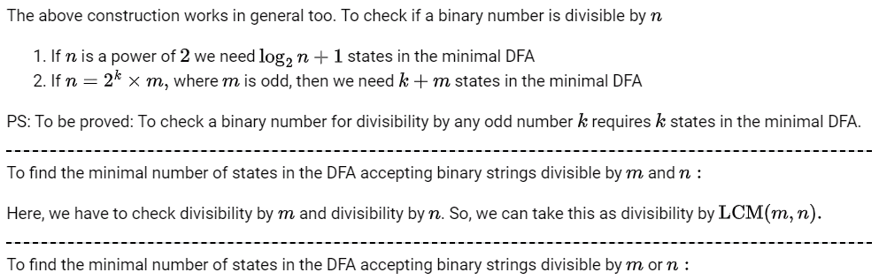LCM(m,n)
12. There is an analogous deterministic Turing machines for every non-deterministic Turing machines.
13. See page no 8 plz.
14. Sq(L)={ww:w∈L}, Do(L)={wx:w,x∈L}. Difference between sq and do is in sq first w and second w should be same which is not CFL clearly so if L is regular or CFL then sq is CSL. W = anbn so ww = anbnanbn. And do is nothing but L.L concatenation. So, wx is clearly both CFL and Regular.

**Compiler Design** :

1. 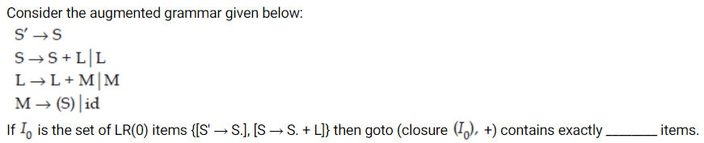

In this question LR(0) items are written and you have wrote LR(1) item which is 9 but here answer is 5.

1. Strength reduction : 8*i can be replaced by i<<3
2. S→AB∣AC, ε∈ if first(A) = {ε}, ε∈first(B) and ε∈first(C) then now corresponding to S always have multiple entries. As these two production leads to ε we add both production in follow of S. Remember we do not add S-> ε in follow of S because this production is made of.
3. i is Loop induction variable means i variable is used in loop example **for(int i=0;i<n;i++){Some random operation on i or any other variable.}**
4. In calculating tokens count repeated variables also. Do not look at marks or something like that.
5. 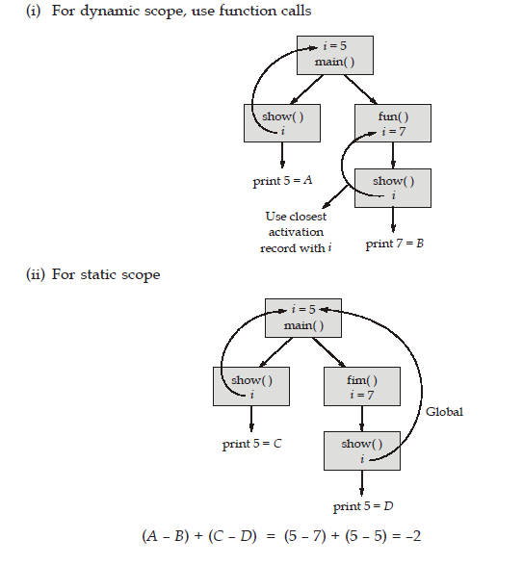Static scope is our usual programming and dynamic scope is last value inserted in activation records. So if question askes for static and dynamic scope draw this tree diagram and then solve.
6. Data flow analysis is optional it is not necessary.

**Operating system** :

1. First block of any file has 0 as its index so if it starts from 41 and you want to read 3 then it becomes 44 not 43.
2. Total CPU utilization = Task involving CPU / (Task involving CPU + remaining I/O)

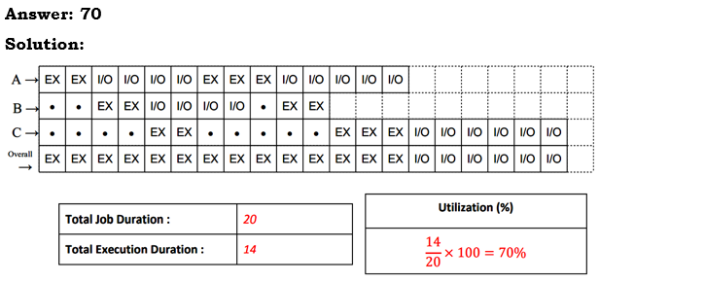

1. 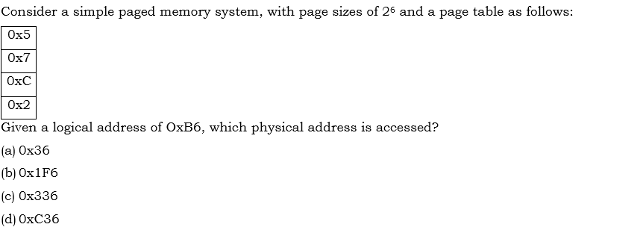In this question you got 2 as index from 0xB6. So now index that box you will find 0xC will be frame index then add that into page offset C is answer.
2. If wait(NULL) is used in parent code then parent have to wait for completion of one its child process then it can execute its next instruction.
3. 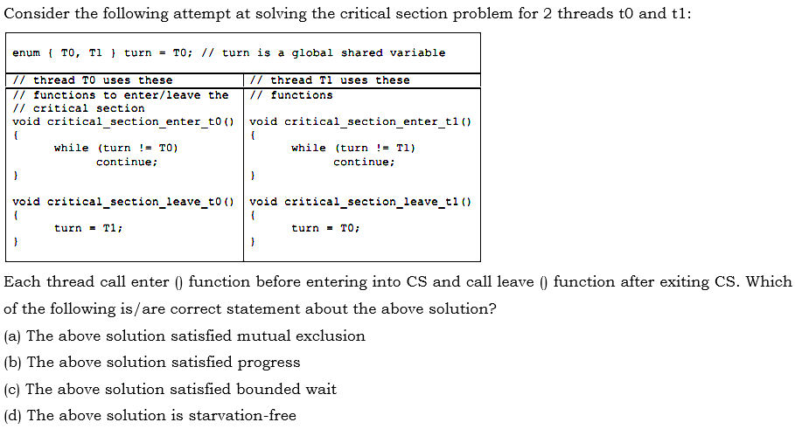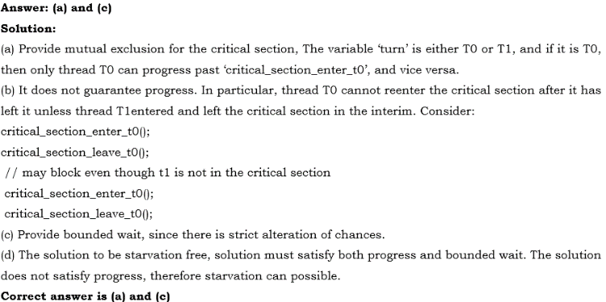

See this you have to check for this condition also for progress.

1. Newly arrive process means process which came first not the processes that came last or latest process.
2. In FCFS there is no chance of starvation. You look at cases first come first serve as name indicate it do justice with all process so no one can starve.
3. Even thought round robin scheduling is used for processes, bounded wait may not be satisfied. This is true because bounded wait exits in processes and round robin is CPU scheduling algo it has nothing to do with critical section problem.

**Database** :

1. Not every 2PL guarantees recoverability.
2. Equi Join means simple join. Now, rows returned by equi join and natural join can be same. But In case of column, Natural join returns Union of column where as Equi join doesn’t.
3.  Here first query may give some result or empty result but second query is invalid as there are no rows B to select B=1. Thus, both of this query is not same. First returns table with no tuple whereas second return invalid error.
4. In unary relation we create one attribute. 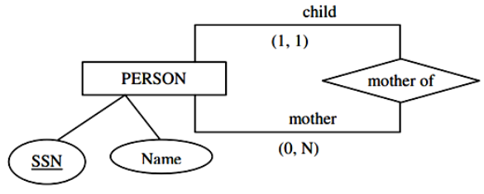 So, Person relation or table becomes PERSON(SSN, Name, MotherSSN(this is random name))
5. For finding conflict equivalance. Do not use diagram approach use conflict approach see if same pair of conflict happens in second Schedule.
6. Minimum number of block used for indexing in B+ tree is same as total number of block in B+ tree.
7. If Question asked like which of the following is/are true? Then BDE 🡪 B is always true because it is trivial.
8. If there is no dirty read in every transaction then it is both recoverable and casadeless.
9. 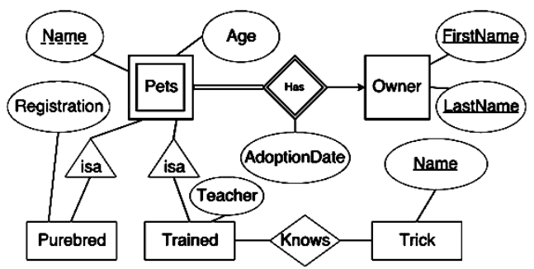In this ISA is there so question is when to make which table. So, if there is total relation between isa and pets so we will not create pets table but we will create purebred and trained table. And in current scenario there is no total relation between isa and pets so we will create pets table also including purebred and trained. There are some cases when there is a dependency between purebred and trained in that case, we create one more table which contains all attributes of purebred, trained and pets.
10. If some tuples satisfy condition which will result in 28, 64, NULL values so avg is not sum/3. But sum/2.
11. 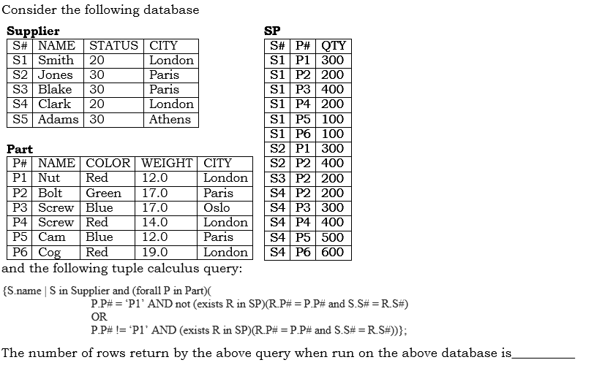 In such queries where you are not able to make conclusion try to understand the meaning. It says that select s.name such that s should be tuple in supply table and for all P tuple from Part table following condition should be true.
12. 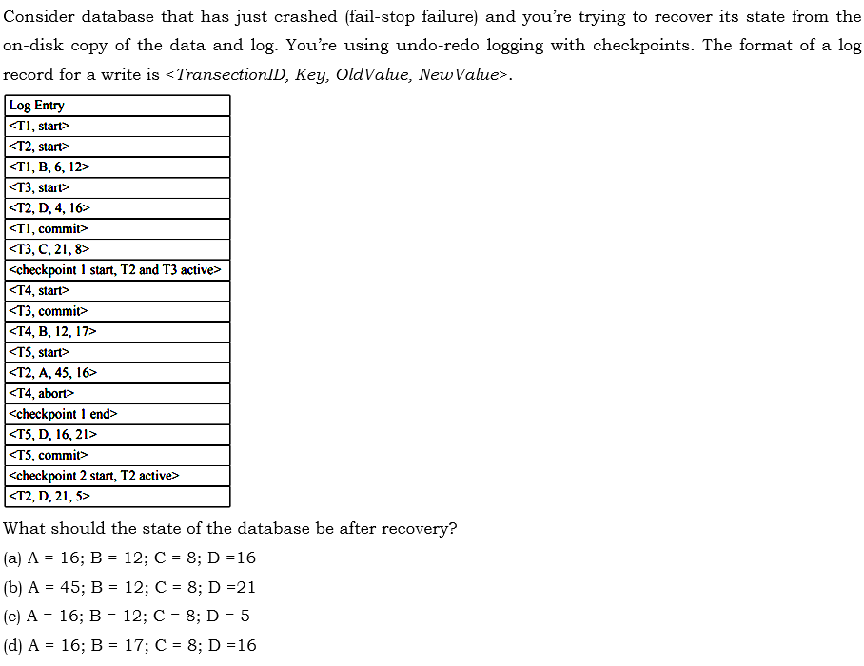

Checkpoint means that all the values written in database so we cannot change that values. First undo operation performs in reverse order. Then redo operation performs in forward direction. Transaction which are not committed need to undo and committed transaction need to redo. First before check point C has value 8 and after check point it does not change so C=8. Now, A = 45 B = 12 and D=16. Now redo operation in forward direction. We only have to redo T3 and T5 so T3 does not change but T5 changes the value of D so we do D=21. So finally, A=45, B=12, C=8, D=16.

1. B+tree. There is no record pointer in non-leaf node. If you forgot slightly plz see the tree. But In B tree there record pointer for each key.

**Computer Network** :

1. ICMP has nothing to do with TCP Timer. It will not generate error message if this timer got out.
2. DBA of subnet mask means direct broadcast address which is nothing but all subnet mask followed by all one.
3. 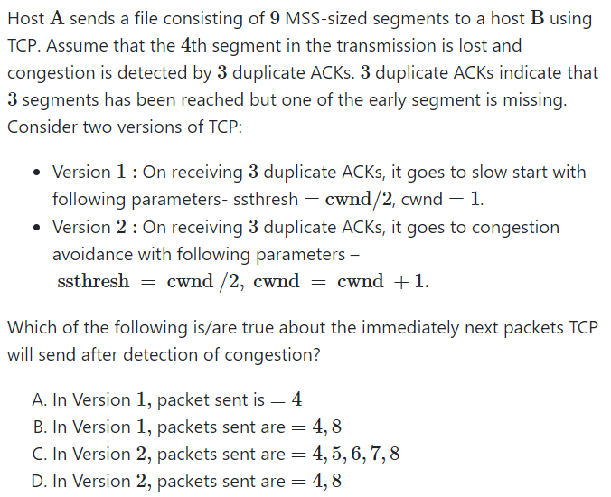 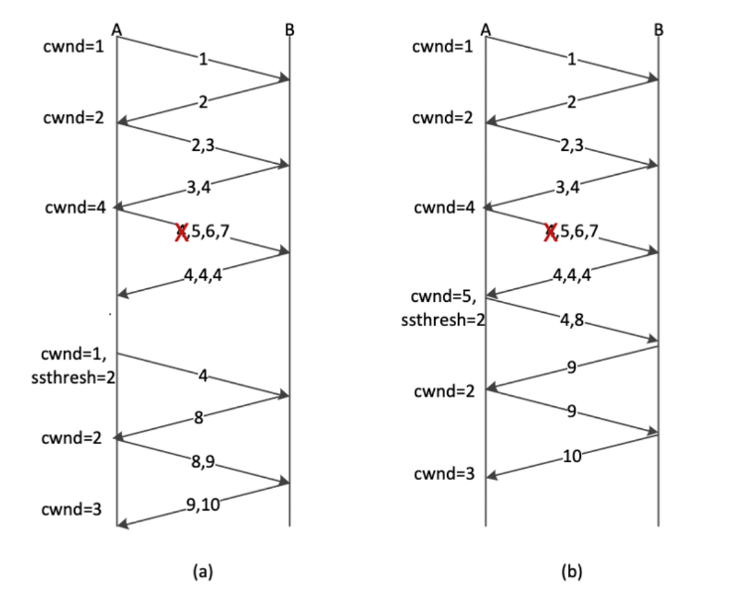

In version 2, Before 3 duplicate ACKs, its size is four, and packets in window are 4,5,6, and 7. Now it cannot move its window past 4 until it gets ack for 4. Now after congestion sender window size is 5 but the content of the window is still 4,5,6,7,8. and we don't have 9 yet in the window.

1. In circuit switching there is not delay of link only propagation delay and first link or hop delay is there.
2. In forwarding table aggregation first draw combine all same next hop or same interface addresses then perform aggregation. In aggregation combine address having longest common addresses within subnet mask.
3. Between two devices two interface exists. Interface means physical medium. 1 from first point to second and 2 from second to first.
4. 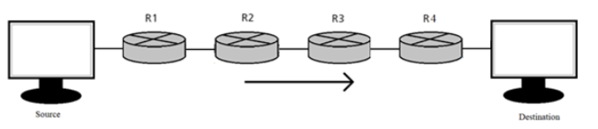In this network 10 interface and 5 forwarding table exists. 5 because source can have multiple routers so it needs one forwarding table whereas destination receives packets from default router so, it do not need router.
5. ICMP, IGMP, OSPF and UDP, they all run on top of IP. See on top of means on IP and above IP it does not mean like above IP. On top of English is easy.
6. HTTP, FTP are the only protocols that uses multiple TCP connection. HTTP uses multiple connection in non-persistent connection and FTP uses two TCP connection one for data and one for control signal.
7. Contention slot in CSMA/CD is 2Tp. See your notes if possible.
8. Number of subnets is 24-2.
9. The maximum number of bits that Class C can use is 24 according to you but remember first three bit of Class C is used for recognition purpose to only 21 bit are used.
10. Smallest value of cwnd1+cwnd2 for which the link joining the two routers could stay busy all the time is same as asking bandwidth delay product. Which is nothing but Number of bytes which can be sent while 2Tp.
11. Look for byte and bit in every computer network sum.

**Aptitude** :

1. In every question of aptitude check unit.
2. A merchant uses a weight of 125 gram instead of 100 gram while buying an article. He used 80 gram instead of 100 gram while selling. He marked up the price by 20% and then offers 20% discount. Find the overall profit or loss percentage.

**Answer** : While buying ( the person could have got 100g for rate X Rs/g, but he  got 125g → GAIN 25%) [1.25]

While selling ( the person could have sold 100g for rate X Rs/g, but he sold only 80g → GAIN 25%) [1.25*1.25]

Marked Up price by 20% → GAIN 20% [1.25*1.25*1.2]

Gave discount 20% → LOSS 20% [1.25*1.25*1.2*0.8 = 1.5 → 50% OVERALL PROFIT ]

1. In case of cylinder and cone do not forget to add base area in calculating total surface area.

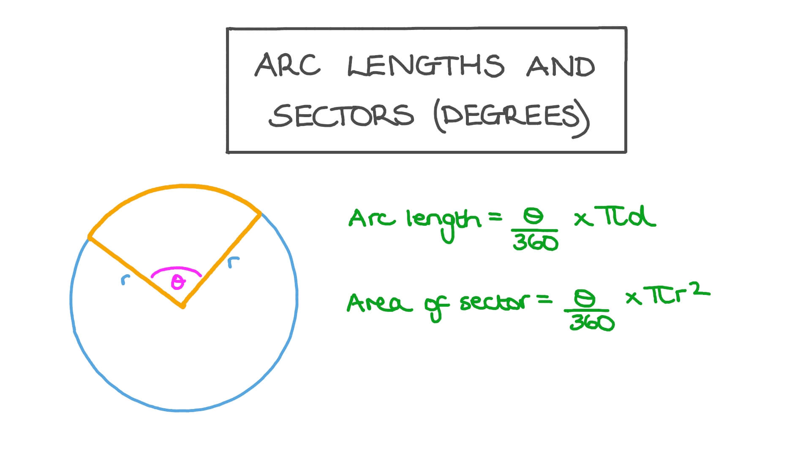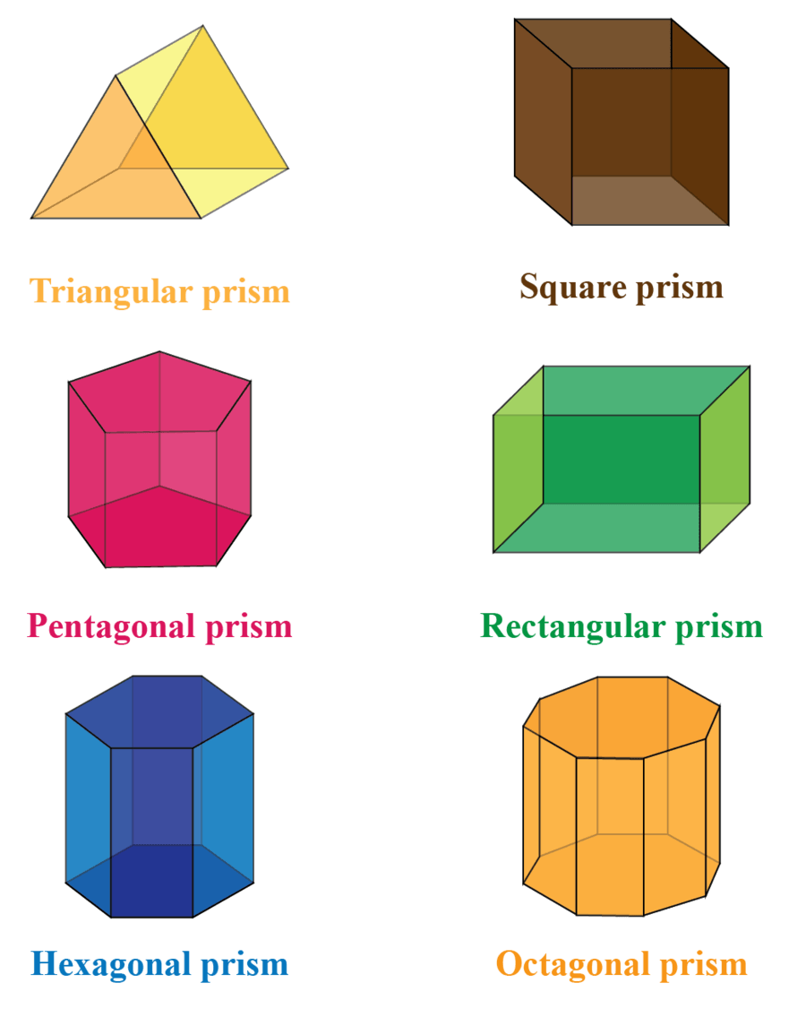

1. Every equilateral triangle is also an isosceles triangle.
2. According to Fermat’s little theorem : if p is prime number and a is any number. 
3. 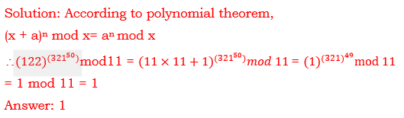
4. In solving question related to combination try to apply two techniques addition and second is calculating whole and then subtracting odd cases one by one.